Roles and Requirement Analysis in Agile
UNIT 2
Describing the Different Roles
1. Agile Roles
- Agile emphasizes collaboration, communication, self-organizing teams, and delivering customer value.
- Roles can vary depending on the Agile methodology being used.
A. Deep Dive into Scrum Roles
1. Product Owner
The Product Owner represents the business and customer perspective.
Main responsibilities:
- Creates and communicates the product vision.
- Represents customer and business needs.
- Creates and maintains the Product Backlog.
- Prioritizes requirements according to business value.
- Makes decisions about product features and releases.
- Works closely with the development team.
Key idea: The Product Owner ensures that the team works on the most valuable requirements first.
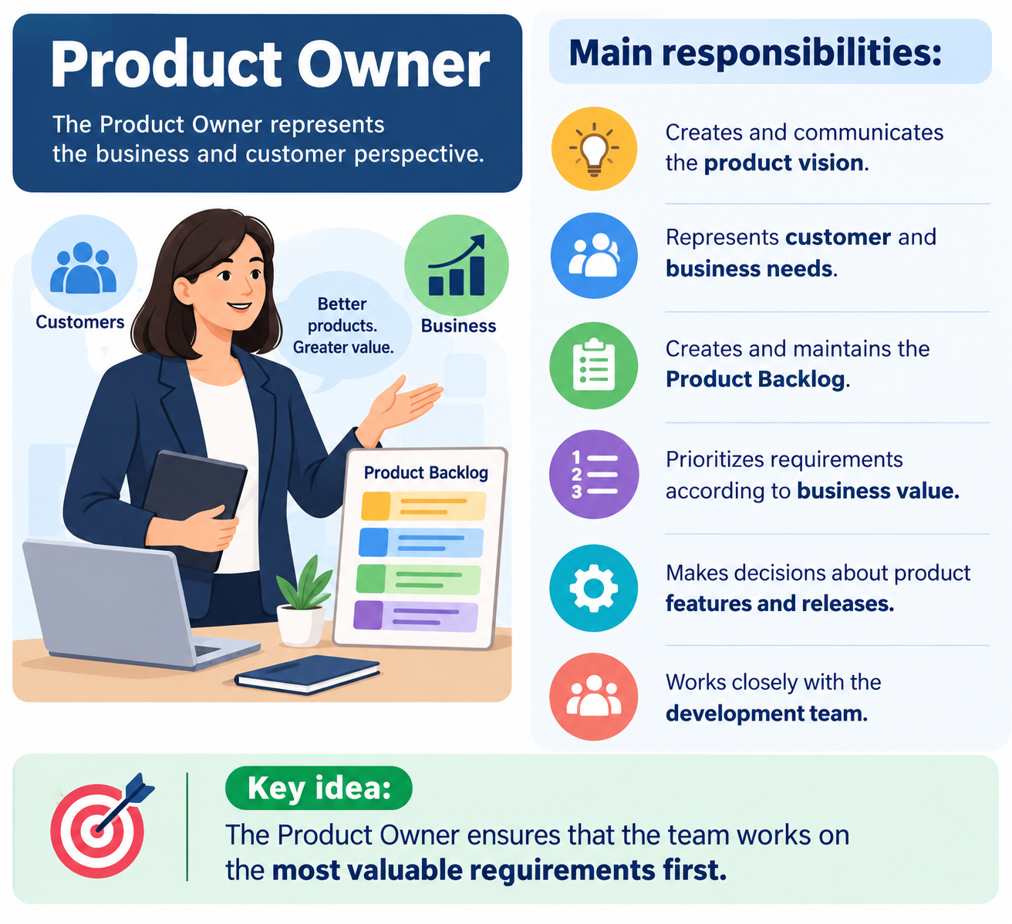

2. Scrum Master
The Scrum Master supports the Scrum process and helps the team work effectively.
Responsibilities include:
- Facilitating Scrum activities and meetings.
- Helping remove obstacles or barriers.
- Ensuring that Agile and Scrum principles are understood.
- Supporting communication and collaboration.
- Protecting the team from unnecessary disruptions.
- Helping the team improve its way of working.
Key idea: The Scrum Master is primarily a facilitator and coach, rather than a traditional command-and-control manager.
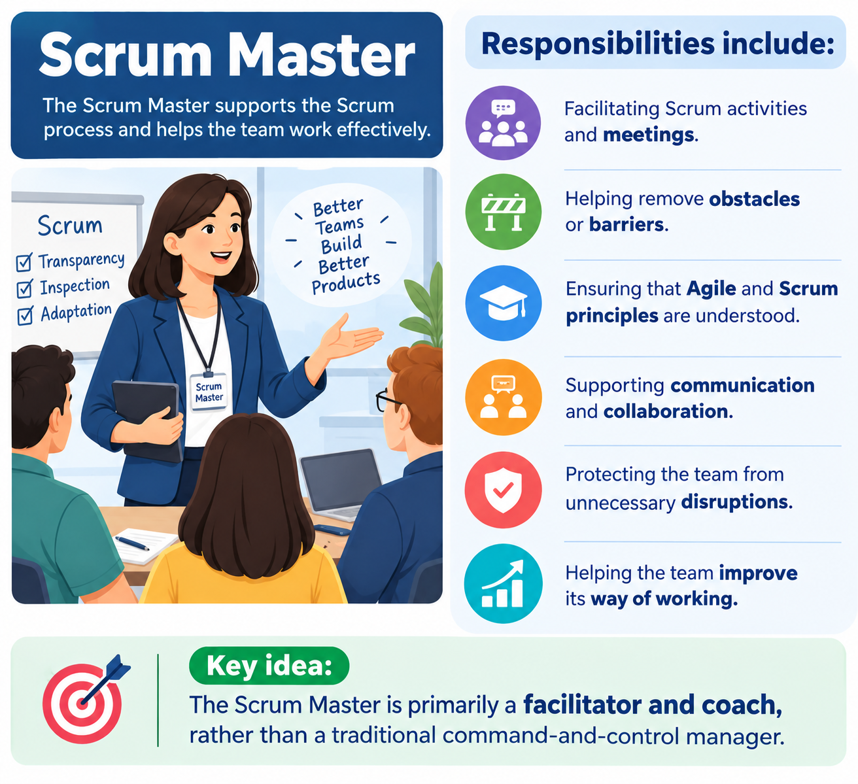

3. Scrum Team / Development Team
The development team performs the work needed to create the product.
Characteristics:
- Cross-functional.
- Collaborative.
- Self-organizing.
- Responsible for designing, developing, and testing the product.
- Shares responsibility for delivering working product increments.
Agile principles emphasize that the best requirements, architectures, and designs can emerge from self-organizing teams.
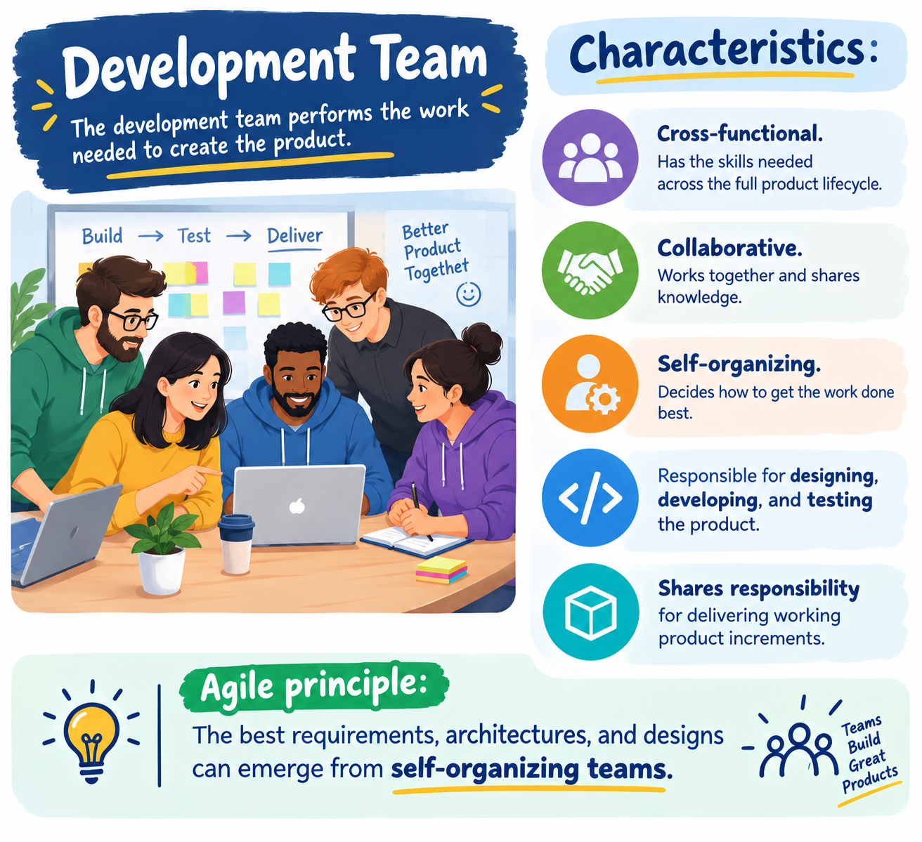

B. Roles in Other Agile Methodologies
Different Agile approaches may use different names for similar responsibilities.
1. Project Sponsor
The Project Sponsor:
- Provides authority and funding.
- Supports and approves the project.
- Sets broad objectives and direction.
The role may also be called an executive sponsor, project sponsor, or, in some contexts, a project champion.
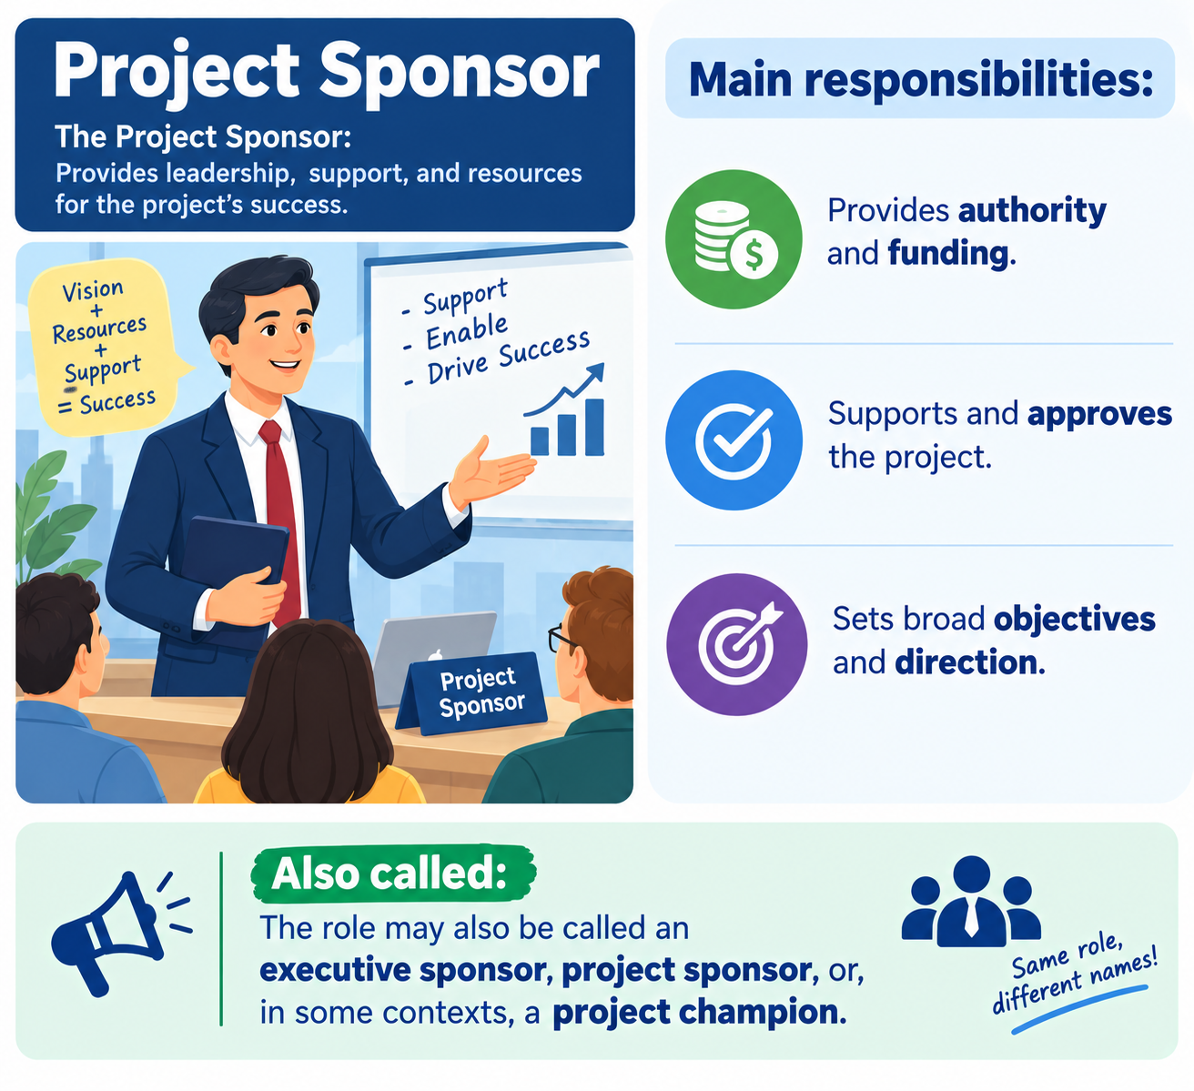

2. Requirements Gatherer
This person:
- Understands customer and user needs.
- Collects requirements.
- Explains business value.
- Communicates the product vision.
Equivalent roles include:
- Product Owner in Scrum and Lean.
- Customer in Extreme Programming (XP), representing end-user needs and priorities.
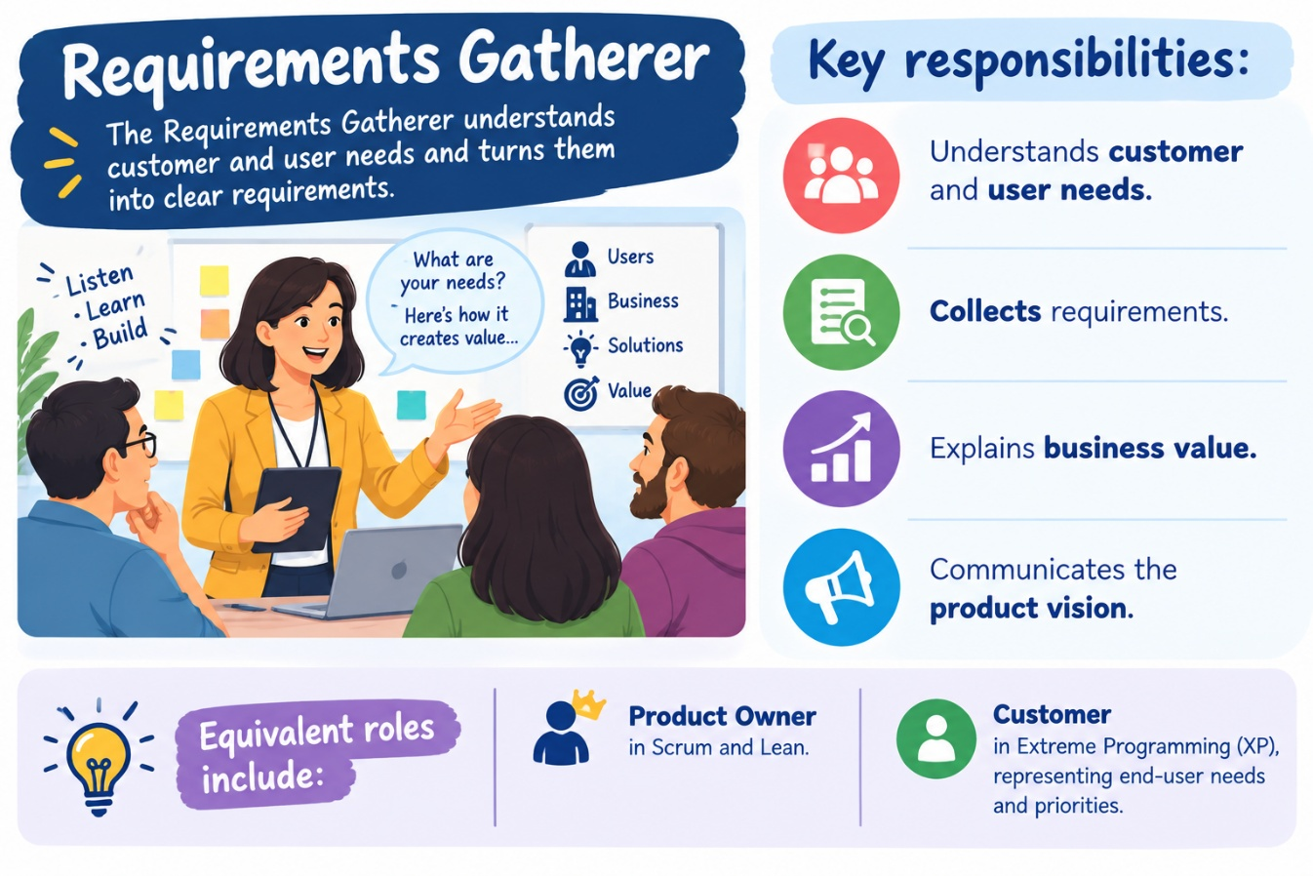

3. Project Manager
In Agile organizations, some traditional project-management responsibilities may be distributed among other roles.
Responsibilities may include:
- Managing project approval and funding.
- Tracking risks and issues.
- Supporting communication.
- Monitoring project progress.
In mature Agile teams, some of these responsibilities are shared by the Product Owner, Scrum Master, and team.
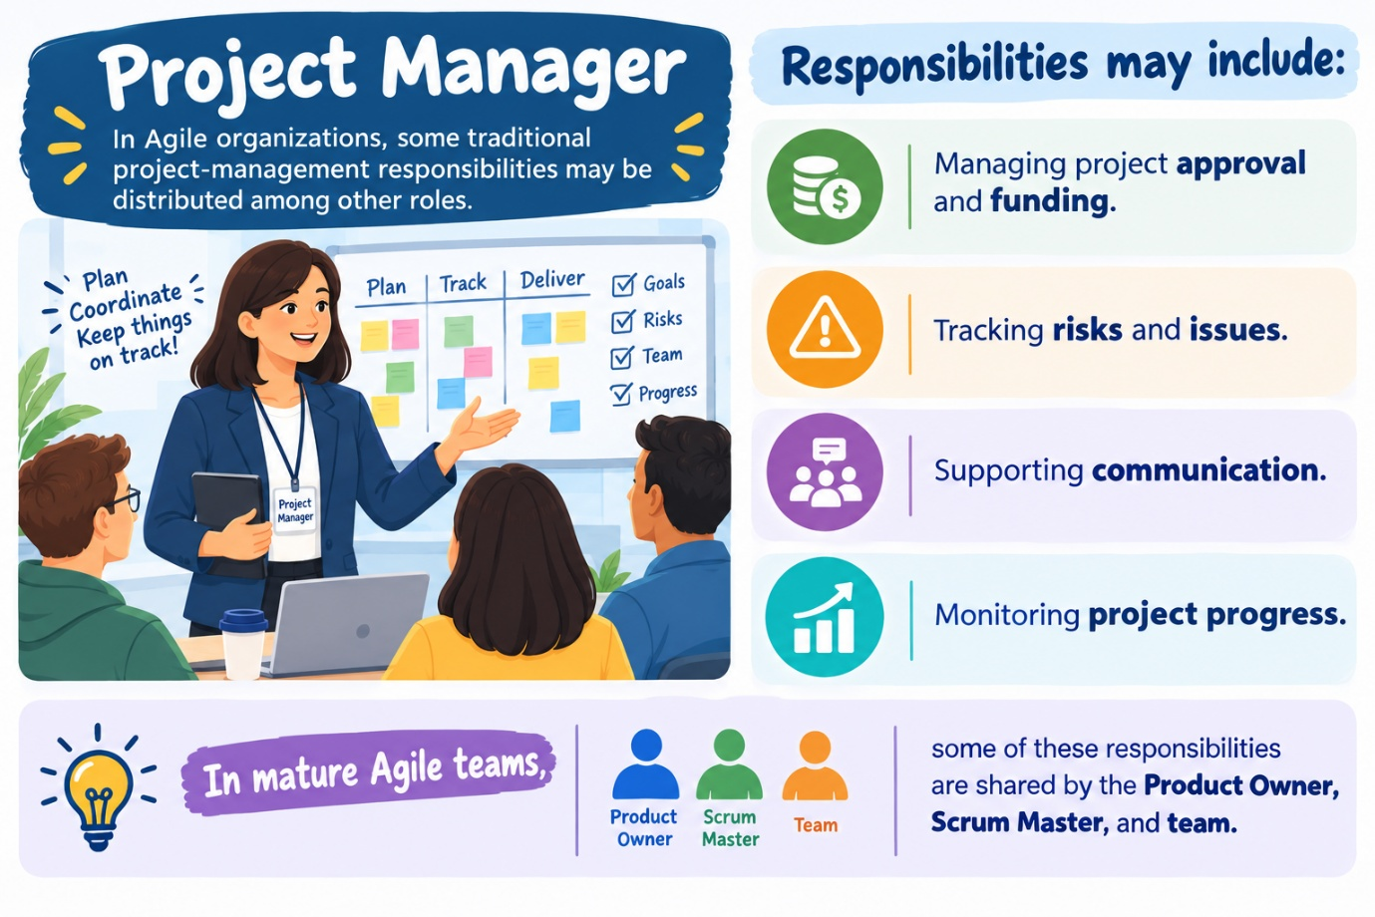

4. Team Coach / Agile Coach
An Agile Coach:
- Helps teams adopt Agile practices.
- Provides training and guidance.
- Improves consistency across multiple Agile teams.
- Helps solve organizational and cultural challenges.
- Supports continuous improvement.
This role is especially useful in large organizations with multiple Agile teams.

5. Architect or Technical Lead
This role provides:
- Technical guidance.
- Architectural expertise.
- Support for technical decisions.
In Agile, architects and technical leads generally work collaboratively with the team rather than making all decisions independently.
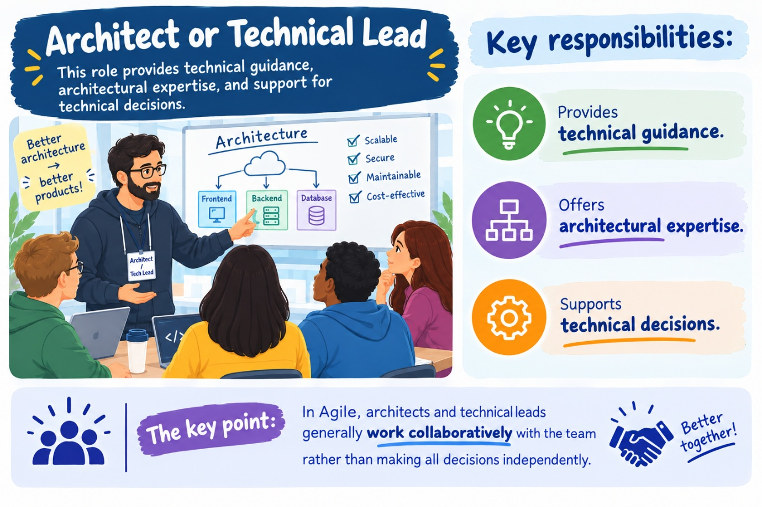

C. Kanban Roles
A major difference between Kanban and Scrum is that Kanban does not prescribe specific roles.
Kanban focuses more on:
- Improving workflow.
- Identifying bottlenecks.
- Managing the flow of work.
- Continuously improving processes.
Therefore, organizations can retain their existing roles rather than creating new roles simply to follow Kanban.
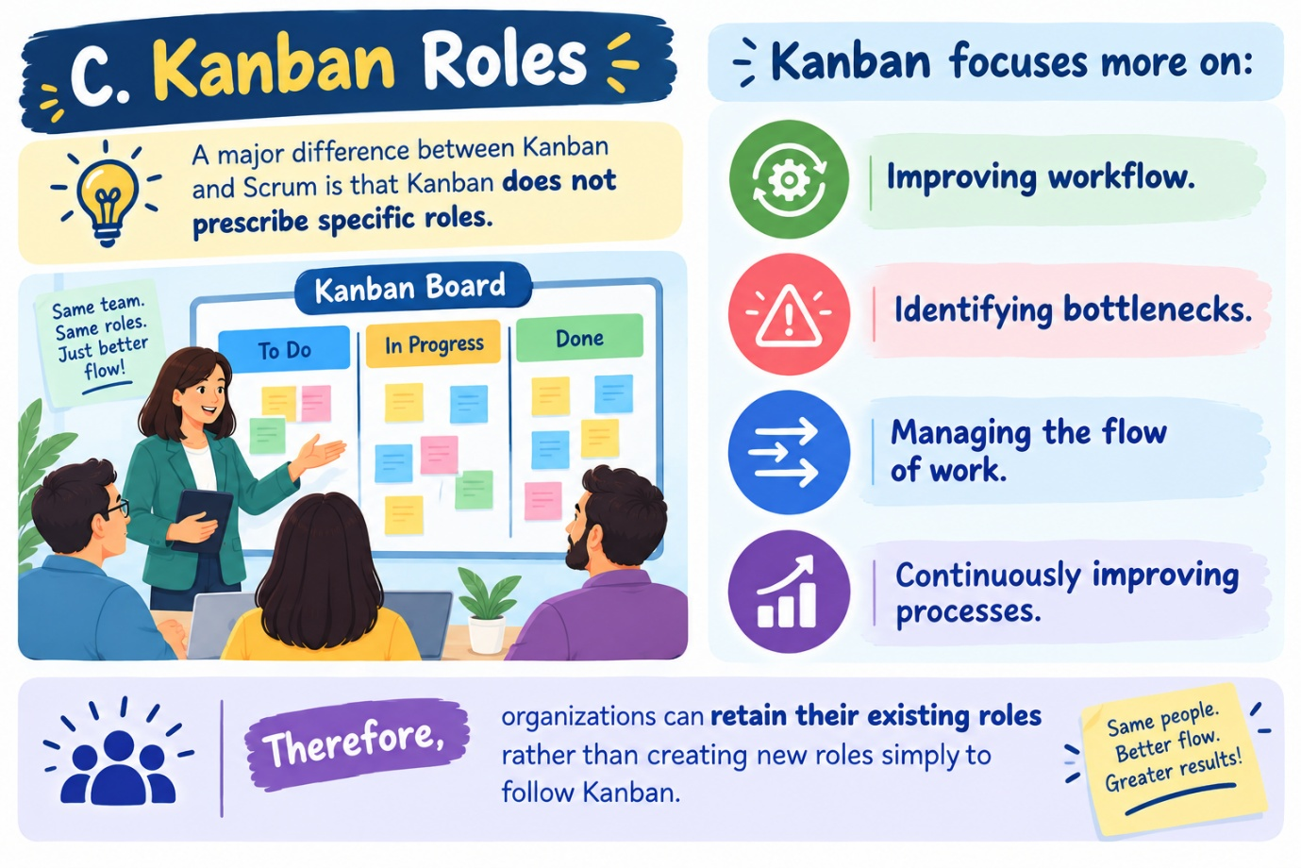

D. Practical Examples of Agile Roles
Illustration about how roles can vary according to organizational size.
1. Start-Up
In a small company:
- People often perform multiple roles.
- A business analyst may also act as Product Owner.
- An IT manager may act as Scrum Master and technical leader.
- Developers and testers may form the Scrum Team.
Advantage: Flexible use of limited resources.
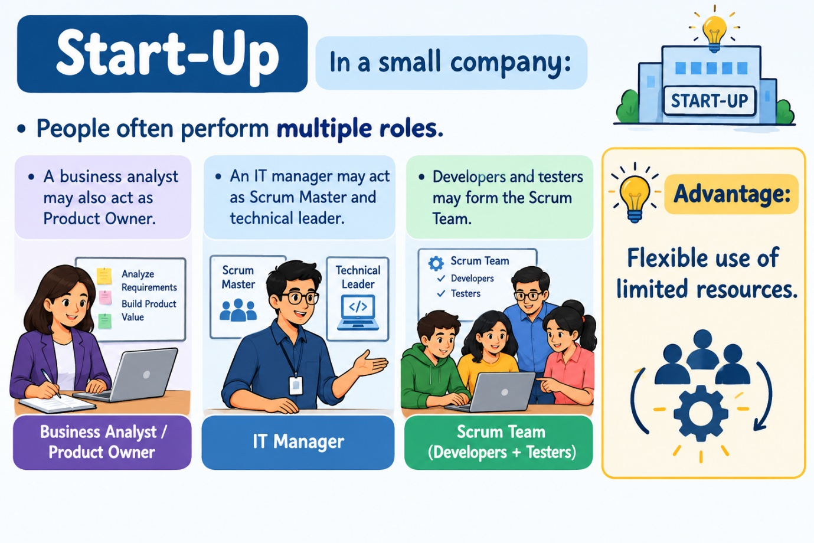

2. Mid-Sized Company
A mid-sized organization may have:
- Multiple Agile teams.
- More specialized roles.
- Separate Product Owners and Scrum Masters.
- Teams working on different applications or products.
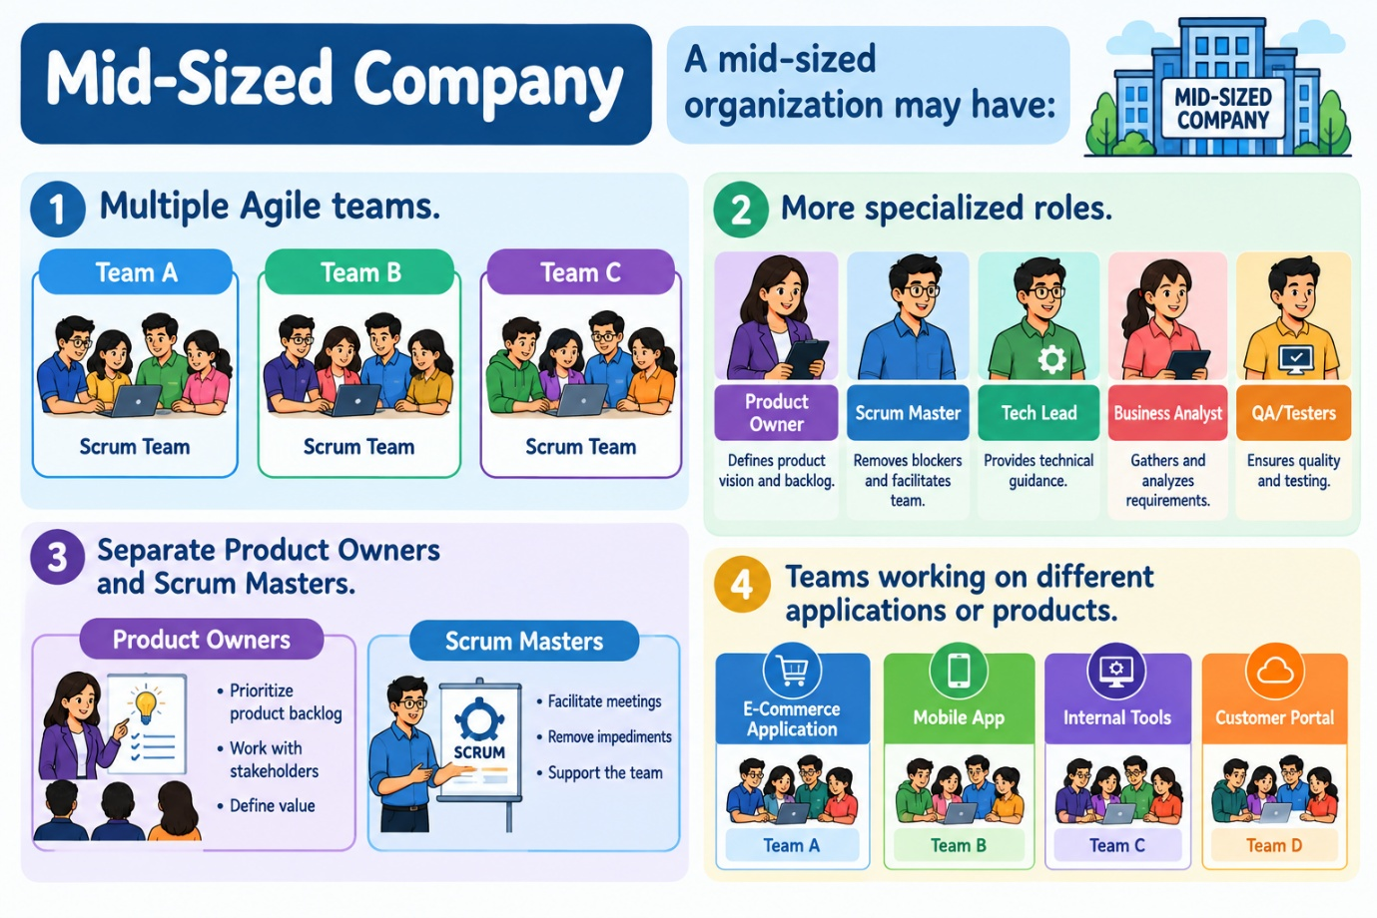

3. Large Multinational Company
A large organization may require:
- Multiple Scrum teams working together.
- Agile coaches.
- Architects and technical leads.
- Strong coordination across teams.
- Additional stakeholders and extended team members.
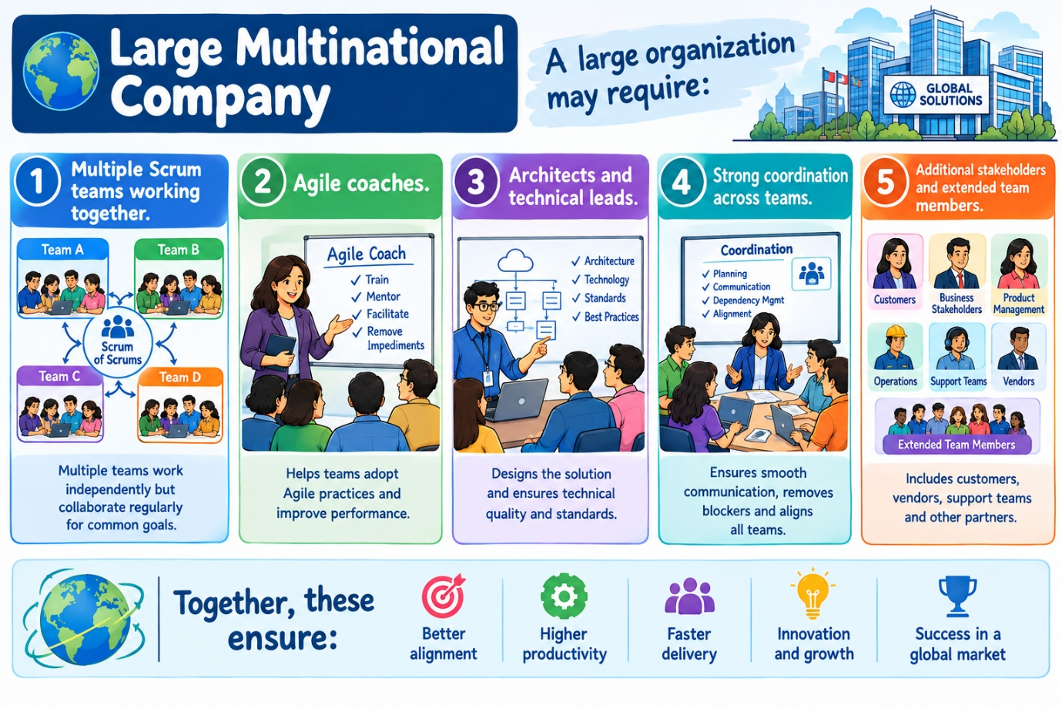

2. Agile Requirement Analysis
A. The New Way to Collect and Document Requirements
Agile changes the traditional way of gathering requirements.
Instead of trying to document every detail at the beginning, Agile focuses on:
- Customer needs.
- Collaboration.
- Simple requirements.
- Continuous discussion.
- Frequent feedback.
- Adaptation to change.
- Delivering business value.
Requirements are gradually refined as the team learns more.
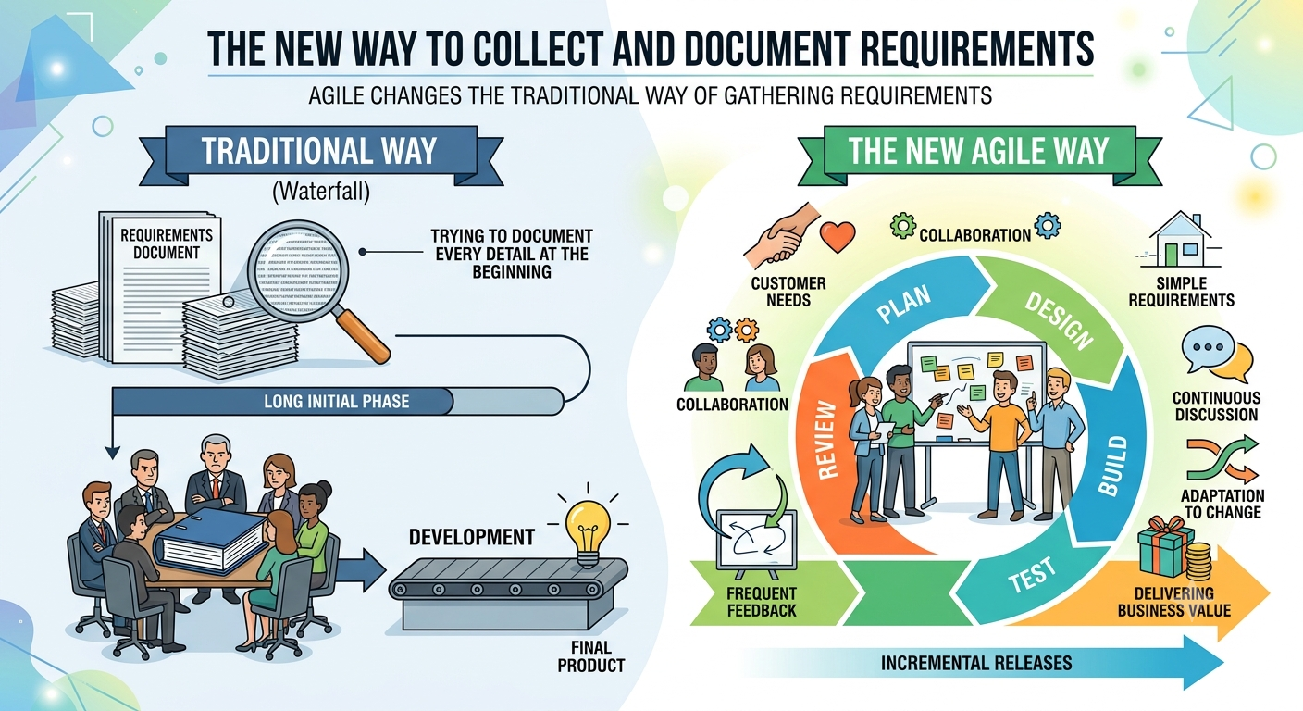

B. Old Form of Requirements Gathering
Traditional Waterfall development requires requirements to be:
- Collected in advance.
- Documented completely.
- Approved before development begins.
Problems with the old approach
- Requirements change
  - Markets and customer needs evolve.
  - It is difficult to predict every requirement at the beginning.
- Lack of communication
  - Business people may prepare requirements separately from developers.
  - Developers may have little opportunity to ask questions or suggest improvements.
- Difficulty handling change
  - Changes can become expensive and difficult once development has started.
- Heavy documentation
  - Large documents can become outdated.
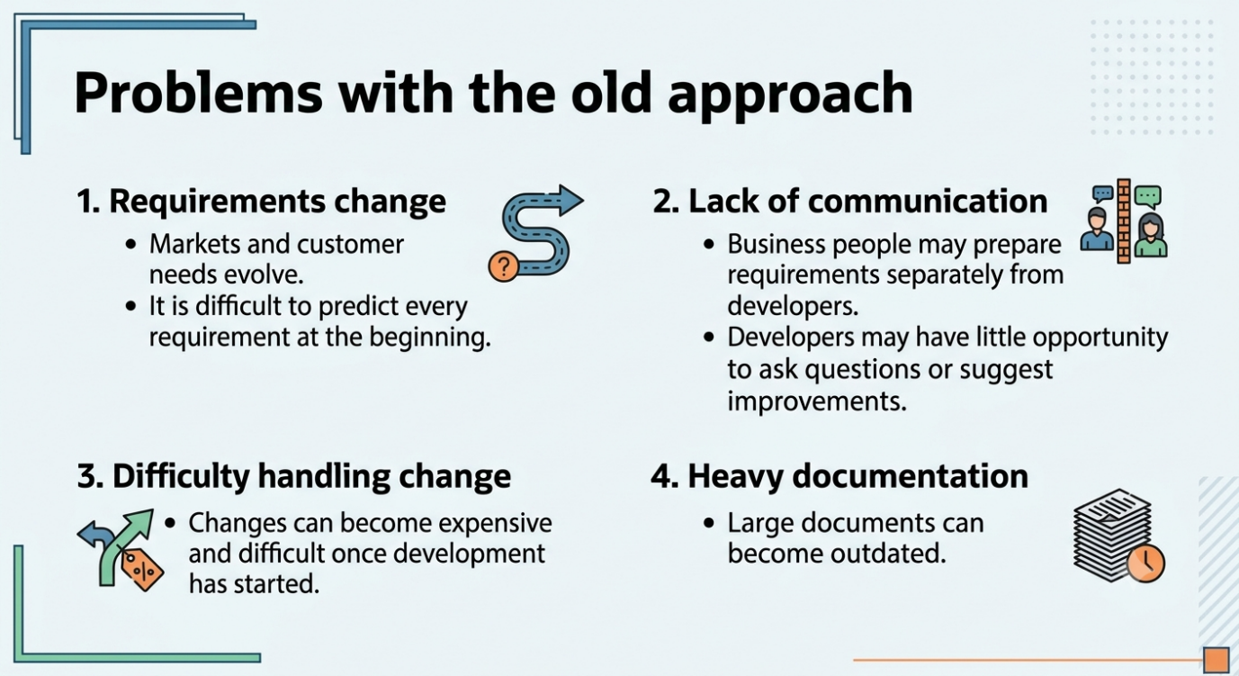

3. Agile Requirements in Scrum
In Scrum, requirements are commonly expressed as User Stories.
A user story should be small enough to be:
- Designed.
- Developed.
- Tested.
within a single Sprint or iteration.

A User Story answers four questions
What?
What feature is being requested?
Who?
Who will use or benefit from the feature?
Why?
What value does the feature provide?
When?
The timing is generally determined through prioritization, based on urgency and business value.
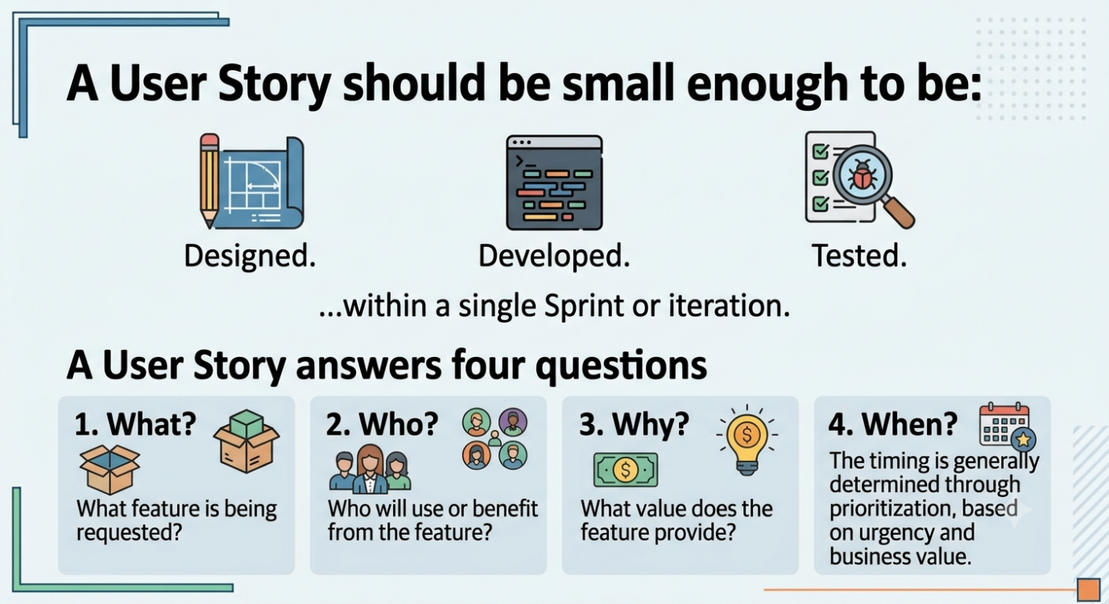

A. User Story Format
A commonly used structure is:
As a [type of user], I want [some goal] so that [some reason/value].
Example:
As an online customer, I want to track my order so that I know when it will arrive.
This format clearly identifies:
- The user.
- The required functionality.
- The business or user value.
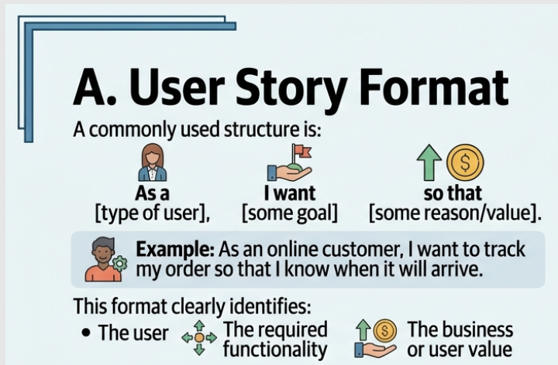

B. Epics
An Epic is a large requirement that is too big to complete in a single Sprint.
Therefore, an Epic is divided into smaller User Stories.
Example
Epic: Online Shopping System
Possible User Stories:
- Search for products.
- Add products to cart.
- Make payment.
- Track an order.
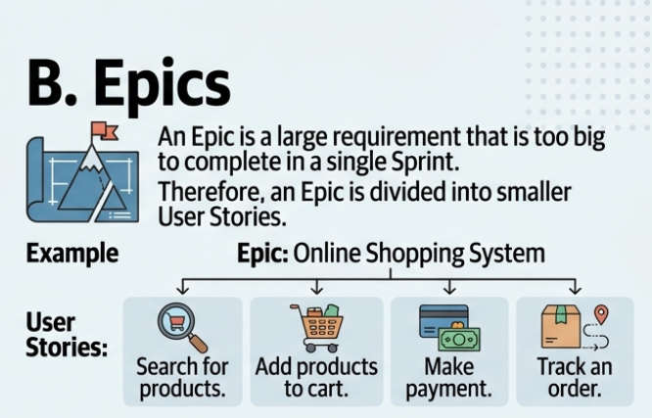

C. Acceptance Criteria
Acceptance criteria define the conditions that must be satisfied for a user story to be considered complete.
They help:
- Clarify expectations.
- Reduce misunderstandings.
- Support testing.
- Confirm that the requirement delivers the intended value.
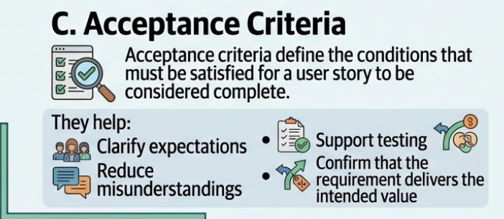

D. User Story Writing Best Practices
Good user stories should be:
- Clear.
- Simple.
- User-focused.
- Valuable.
- Small enough for an iteration.
- Easy to discuss.
- Prioritized according to value.
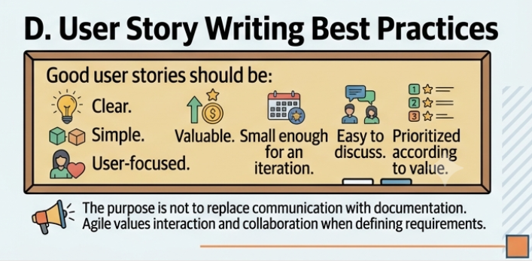
The purpose is not to replace communication with documentation. Agile values interaction and collaboration when defining requirements.

4. Additions and Considerations from Other Methodologies
A. Extreme Programming (XP)
XP also uses User Stories.
Important points:
- Stories describe what customers want the system to do.
- Customers or customer representatives play an important role.
- Stories are useful for understanding scope.
- Stories also help estimate the effort required.
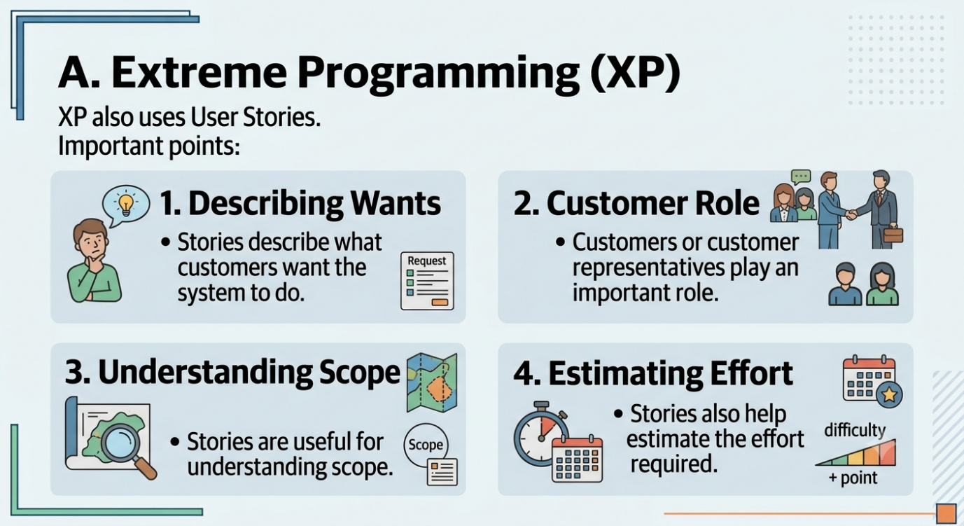

B. Dynamic Systems Development Method (DSDM)
DSDM emphasizes delivering the most critical functionality first.
It uses MoSCoW prioritization:
Must Have
Essential requirements without which the system cannot function properly.
Should Have
Important requirements that may be omitted if necessary because of time or resource constraints.
Could Have
Useful enhancements that are not critical.
Want to Have
Requirements that provide limited value and are lower priority.
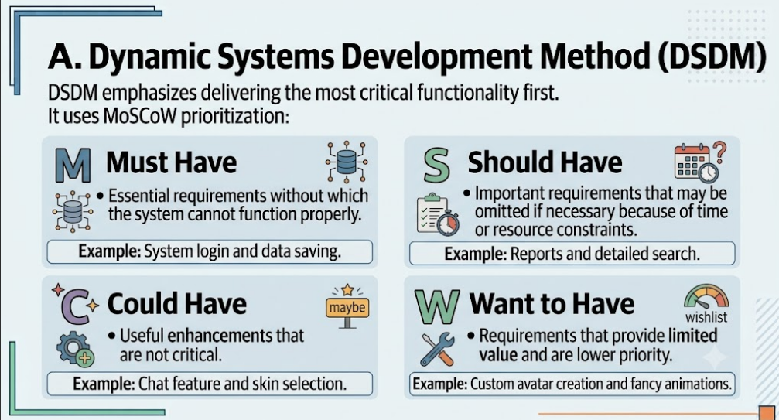

5. Enhancing Requirements
Requirements can be improved by adding more information about users and business value.
A. Personas
A Persona is a fictional representation or archetype of a target user.
Personas help teams understand:
- Who the users are.
- What their goals are.
- What problems they face.
- How they may interact with the product.
Benefits
- Improves user-centered design.
- Helps teams make design decisions.
- Keeps development focused on real user needs.
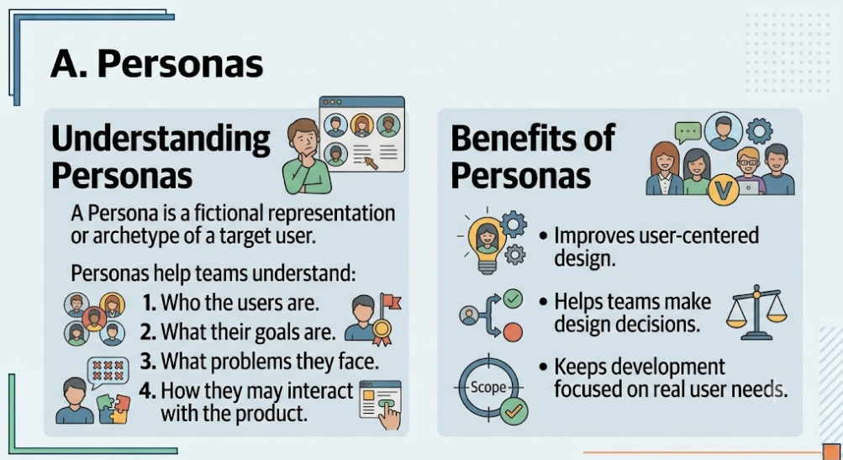

B. Human–Computer Interaction (HCI) and Usability
Agile requirements should consider how users interact with the product.
Important factors include:
- Ease of use.
- User experience.
- Navigation.
- Accessibility.
- User behavior.
Usability should not be treated as a one-time activity. It can evolve and improve throughout iterative development.
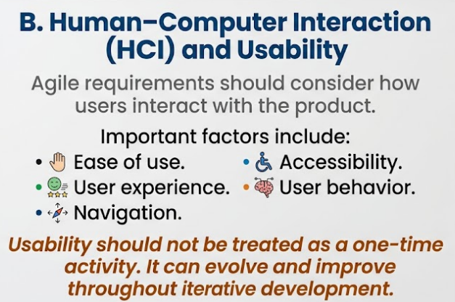

C. Business Value
Not every feature provides equal value.
The Product Owner must consider:
- Customer value.
- Market needs.
- Revenue potential.
- Competitive advantage.
- Time sensitivity.
A key responsibility is ensuring that the team focuses on high-value requirements rather than spending resources on low-value features.
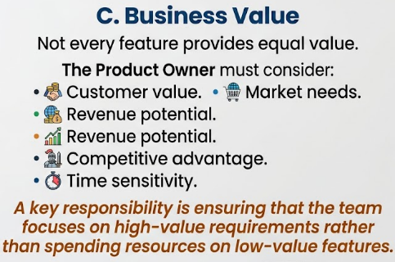

6. From User Stories to Deliverables
User stories are small building blocks of larger product development.
Process
Product Vision → Epics → User Stories → Sprint Work → Product Increment → Release
- Individual user stories may not be sufficient for a market release.
- Several completed stories may need to be combined to create a meaningful deliverable.

A. Release Management
Release management involves deciding:
- Which completed features should be released.
- When the release should occur.
- Whether enough functionality exists to provide value to customers.
Agile supports frequent delivery, but releases must still provide meaningful business value.

B. Features Management
Organizations may experience different priorities between:
- Marketing and Sales teams, which may want new features quickly.
- Development teams, which must consider effort, quality, and technical issues.
Agile helps balance these needs through:
- Prioritization.
- Communication.
- Collaboration.
- Product backlog management.

C. Customer-Specific Code
Teams must consider whether a requested feature:
- Benefits many customers, or
- Serves only a very small number of customers.
Product Owners should focus on features that help most users. Do not spend time on requests that only a few people want, unless those requests make a lot of money or have a very high value.
7. Communication in Agile Requirements
Communication is essential because Agile requirements are intentionally less dependent on detailed documentation.
A. Sharing the Vision
Everyone should understand:
- Why the product is being developed.
- Who it serves.
- What problem it solves.
- What value it provides.
A shared vision helps teams make better decisions when details change.
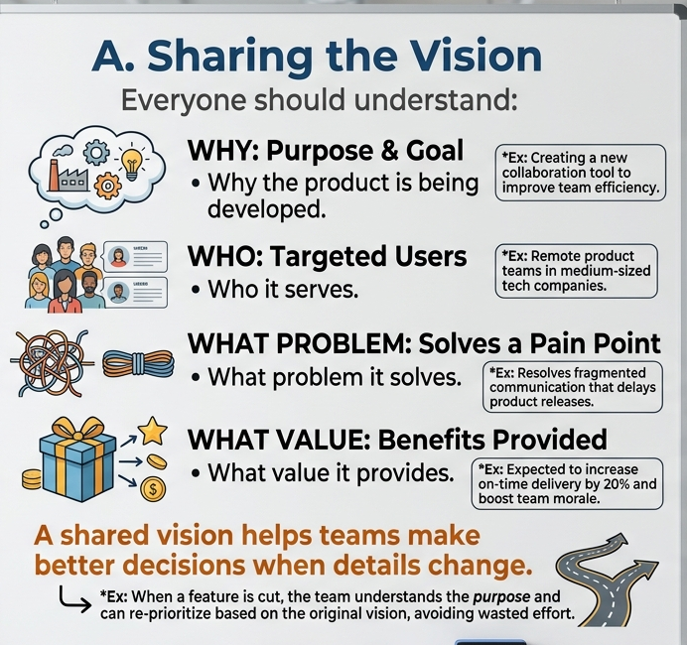

B. Roadmaps
Roadmaps communicate the expected direction of a product.
They can be used:
- Internally, to align teams and stakeholders.
- Externally, to communicate future plans.
However, Agile roadmaps should remain flexible because priorities and market conditions can change.
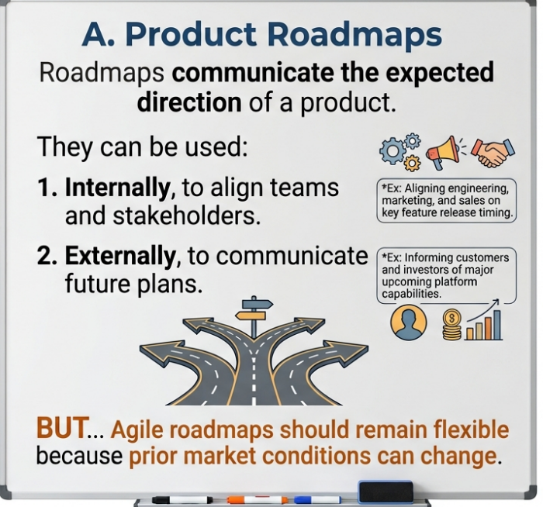

8. Lean Product Development and Minimum Viable Product (MVP)
Lean principles focus on maximizing value and minimizing waste.
Key Lean Principles
- Eliminate waste
  - Avoid work that does not add customer value.
- Amplify learning
  - Development involves discovery and learning.

- Decide as late as possible
  - Delay irreversible decisions until better information is available.
- Deliver as fast as possible
  - Short delivery cycles provide faster feedback.

- Empower the team
  - People doing the work often understand the details best.
- Build integrity in
  - Create products with quality, consistency, and good usability.
- See the whole
  - Consider the complete system rather than optimizing individual parts separately.

Minimum Viable Product (MVP)
An MVP is an early version of a product containing enough functionality to:
- Provide value.
- Be used by customers.
- Test important assumptions.
- Collect feedback.
- Support future improvement.
Agile/Lean Cycle
Build → Deliver → Get Feedback → Learn → Improve
The MVP helps organizations avoid spending large amounts of time building features before determining whether customers actually need them.

Summary
Topic | Key Point
Product Owner | Owns product vision and prioritizes the backlog
Scrum Master | Facilitates Scrum and helps remove obstacles
Scrum Team | Self-organizing team that develops and delivers the product
Kanban | Does not prescribe specific roles
Waterfall Requirements | Detailed and collected upfront
Agile Requirements | Evolve through collaboration and feedback
User Story | Small, user-focused requirement
Epic | Large requirement divided into smaller stories
Acceptance Criteria | Conditions for accepting a completed story
Personas | Fictional representations of target users
Business Value | Helps prioritize important requirements
Release Management | Combines completed work into valuable releases
Communication | Ensures shared understanding and product vision
Lean | Eliminates waste and increases learning
MVP | Smallest useful product used to test and learn

